Title: Modelling and Simulation of a Quarter-Car Suspension System
Name: Ugochukwu Oreh Student

ABSTRACT
This report analyses a quarter-car suspension system operating in two configurations: Cruise mode and Sport mode. Cruise mode represents a comfort-oriented suspension with lower stiffness and damping, while Sport mode uses increased stiffness and damping to improve vehicle handling and body control. The system response to a prescribed road input is investigated using a Simulink model, with key dynamic performance measures used to compare the two modes. The study is extended by introducing suspension bump-stops to limit excessive suspension travel and protect mechanical components. The model assumes linear spring–damper behaviour within the normal operating range and neglects secondary effects such as lateral dynamics and tyre slip.

TASK 1
The quarter-car suspension system is modelled using linear spring–damper elements operating within their normal range. The vehicle masses are assumed to behave as rigid bodies, and only vertical motion is considered. A 0.1 m step road input is applied directly in the Simulink model. Effects such as tyre slip, lateral dynamics, and non-linear suspension limits are neglected.
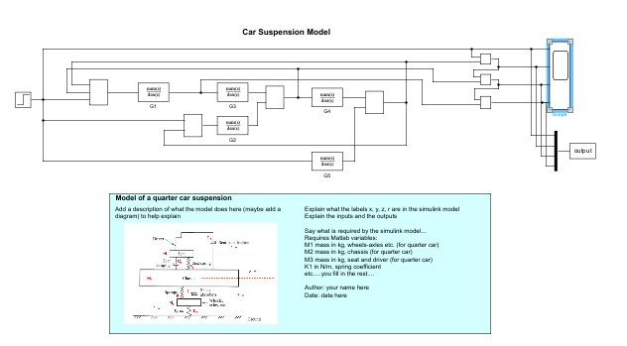
Figure 1: Simulink model of the quarter-car suspension system.
Table 1: Parameters
Parameters | Description | Value
M1 | Wheel Mass | 50 kg
M2 | Chassis Mass | 250 kg
M3 | Seat + Driver mass | 100 kg
K1 | Seat stiffness | 2200 N/m
K2 (Cruise) | Suspension spring | 8000 N/m
K2 (Sport) | Suspension spring | 13000 N/m
K3 | Wheel-Tyre | 120000 N/m
C1 | Drivers Damping | 700 Ns/m
C2 (Cruise) | Suspension damper | 900 Ns/m
C2 (Sport) | Suspension damper | 1500 Ns/m
C3 | Drivers Friction | 300 Ns/m

A step road displacement input of 0.1 m was applied at t = 1 s to represent a sudden road bump. The system response was simulated over a 5-second period.
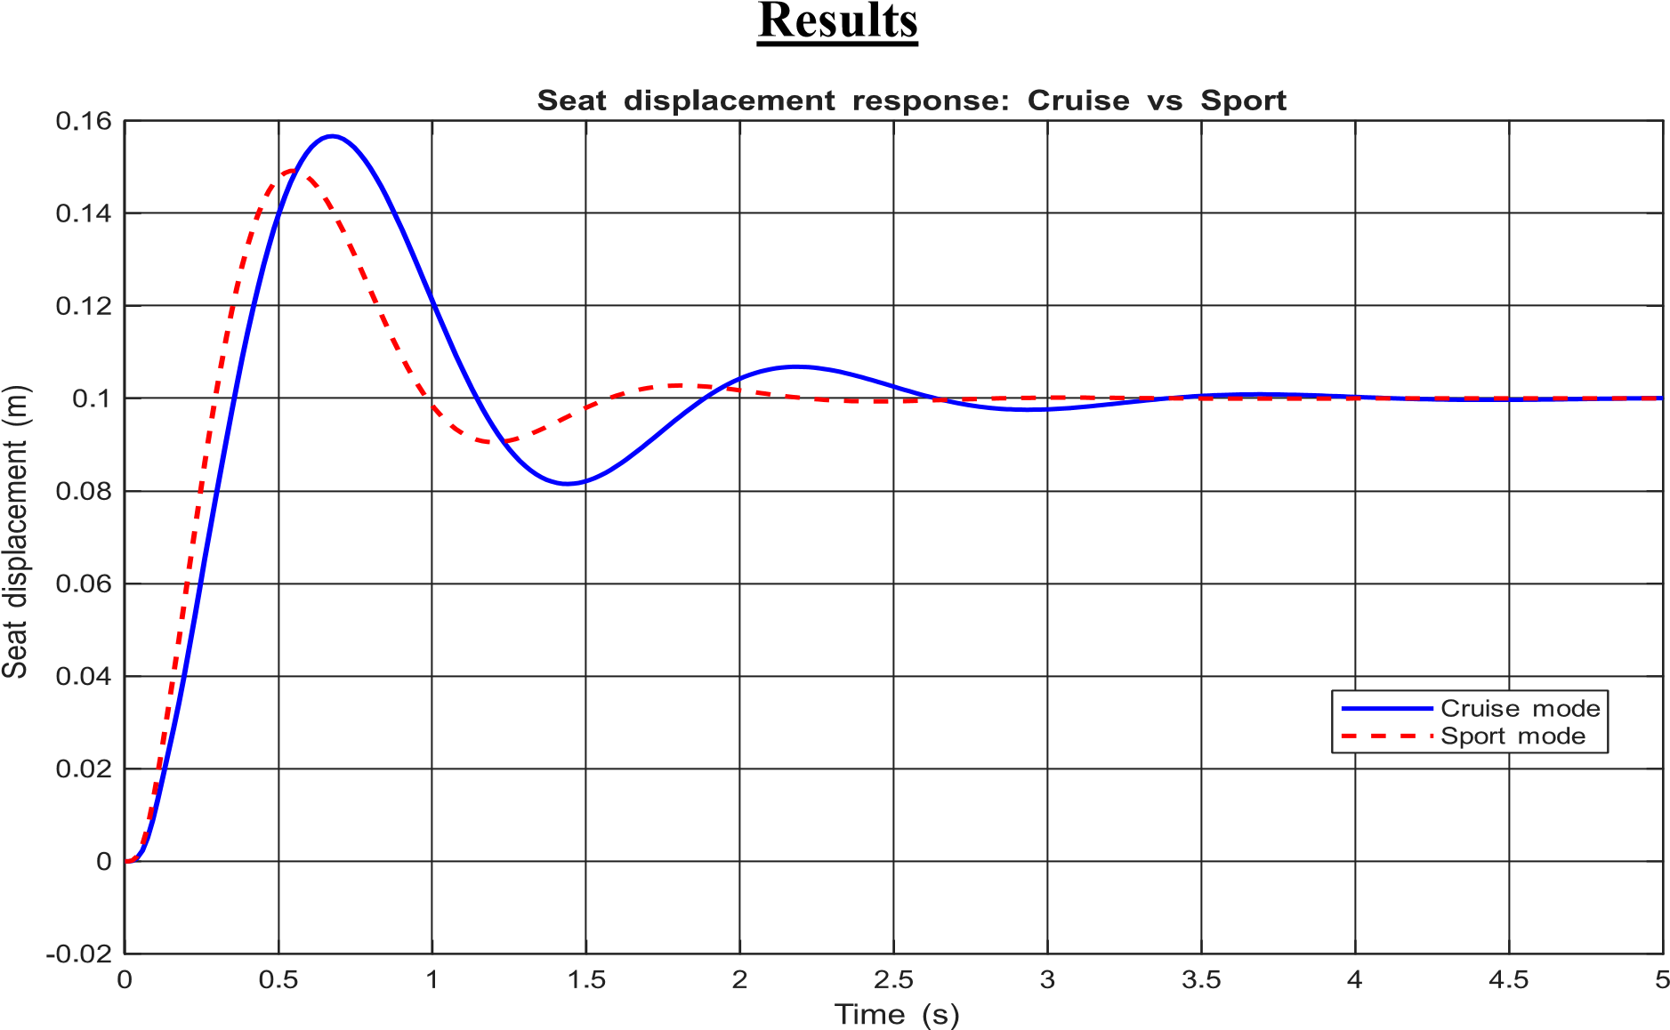
Figure 2: Seat displacement response to a 0.1 m step road input for Cruise and Sport suspension modes.
Metric | Cruise Mode | Sport Mode
Rise Time | 0.2326 | 0.1869
Overshoot | 56.68 | 49.17
Settling time (2%) | 3.0849 | 1.9710
Settling time (5%) | 2.3716 | 1.4070

Discussion
The step response was analysed using the seat displacement output for a 0.1 m road input. The calculated performance metrics are rise time, percentage overshoot, and settling time using both 2% and 5% criteria, as summarised in Table 2. The Sport mode has a shorter rise time (0.1869s) than the Cruise mode (0.2326s). This is caused by the higher suspension stiffness 𝐾₂in Sport mode, which increases the system natural frequency and produces a faster response. Overshoot is lower in Sport mode (49.17%) compared to Cruise mode (56.68%). The increased damping 𝐶₂in Sport mode dissipates energy more rapidly, reducing oscillation amplitude after the step input. Sport mode settles faster for both criteria (1.41 s at 5% and 1.97 s at 2%) than Cruise mode (2.37 s at 5% and 3.08 s at 2%). This reduction is due to the combined increase in stiffness and damping, which accelerates decay of transient oscillations. Cruise mode provides a softer response with greater oscillation, favouring ride comfort. Sport mode provides faster response and reduced oscillation, improving handling and stability at the expense of comfort.
In Task 1, a quarter-car suspension system was successfully modelled and simulated using MATLAB and Simulink. The system response to a step road input was analysed using seat displacement as the primary performance measure. The results demonstrate the impact of suspension parameter selection on ride comfort and dynamic response.

TASK 2
The objective of Task 2 is to prevent excessive suspension travel by introducing mechanical bumpstops that limit the relative displacement between the wheel and chassis to ±2 cm. This modification is intended to protect suspension components from damage while maintaining acceptable vehicle dynamics.
The suspension is assumed to behave linearly until the bump-stop limits are reached. The relative displacement between the wheel and chassis is represented by the signal 𝑦. Bump-stops are modelled as an ideal non-linear limit with no additional damping or compliance. All vehicle parameters and road inputs are unchanged from Task 1.
Bump-stops were implemented in the Simulink model by inserting a Saturation block on the relative displacement signal 𝑦, which represents the suspension travel between the wheel and chassis. The Saturation block was configured with upper and lower limits of +0.02 m and −0.02 m respectively. This ensures that once the suspension travel reaches these bounds, further relative motion is restricted, introducing a non-linear behaviour into the system.
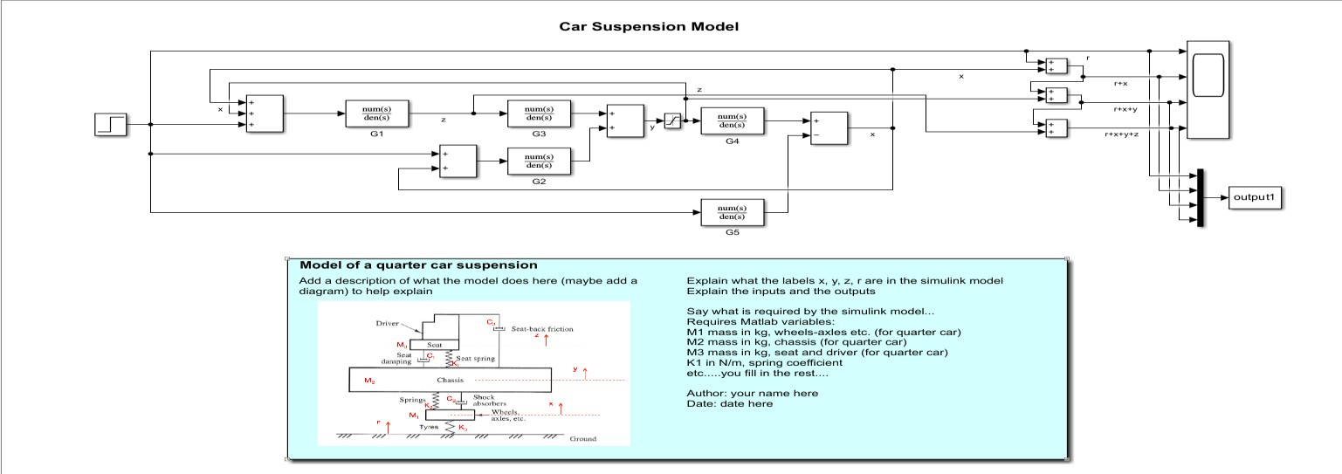
Figure 3:Modified Simulink model showing the Saturation block used to represent mechanical bump-stops limiting the relative displacement

DISCUSSION
The chassis displacement (𝑟+𝑥+𝑦)was analysed before and after the inclusion of bump-stops for both Cruise and Sport suspension modes.
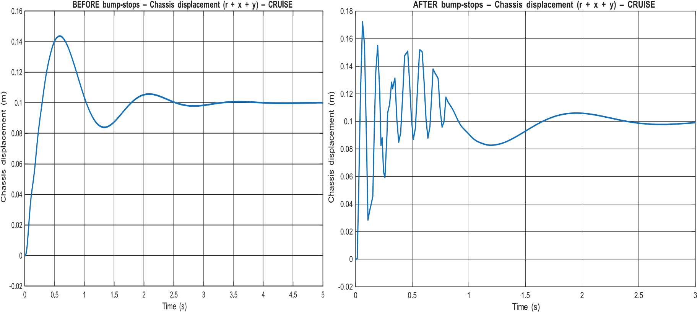
Before adding bump-stops, the chassis displacement had a smooth response with one main overshoot and slowly reducing oscillations. After the bump-stops are added, the response becomes much more oscillatory at the start, this indicates that the suspension reaches its limit and the bump-stops engage. This causes the suspension to behave more stiffly and allows more of the road disturbance to affect the chassis. In both cases, the chassis eventually settles to a similar final position.
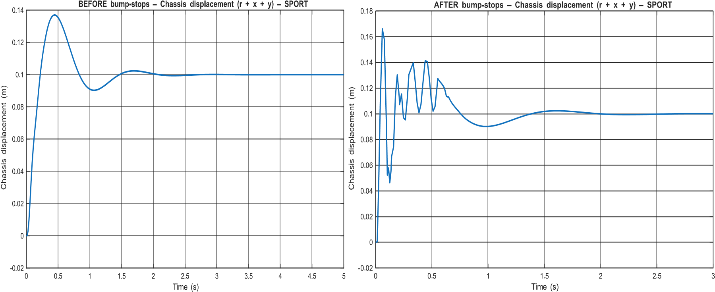
Before adding bump-stops, the chassis displacement in Sport mode shows a quicker and more controlled response with smaller oscillations compared to Cruise mode, because of the higher suspension stiffness and damping. After the bump-stops were added, the initial response becomes more oscillatory with sharp peaks, indicating that the suspension travel reaches its limit and the bumpstops engage. This causes the suspension to behave more stiffly during large disturbances and allows more vibration to go into the chassis. Despite this, the chassis settles to the same final position as before.

TASK 3
Following the design modification introduced in Task 2 (implementation of bump-stops via saturation), the sport-mode chassis response was found to fall outside the required vehicle performance specifications. The specifications state that the wheel absolute displacement, defined as 𝑦(𝑡) = 𝑟(𝑡) + 𝑥(𝑡), must satisfy:
- Percentage overshoot < 72%
- Settling time (2% ) < 0.25 s
To improve the transient performance, the chassis spring stiffness 𝐾₂and chassis damping coefficient 𝐶₂were varied according to the design options given in Table 1.
For this analysis, a step road input was applied to assess the transient response of the suspension system, as required for evaluating percentage overshoot and settling time. The quarter-car model was assumed to be linear and time-invariant, except for the bump-stop saturation introduced in Task 2. Performance metrics were computed using the limited (post-saturation) wheel absolute displacement signal, defined as 𝑟 + 𝑥, in accordance with the task specification. The settling time was defined as the time taken for the response to remain within ±2% of its steady-state value and was obtained using MATLAB’s stepinfo function. All system parameters were held constant throughout the study, except for the chassis spring stiffness 𝐾₂and damping coefficient 𝐶₂, which were varied as part of the design investigation. Each combination of spring stiffness 𝐾₂and damping coefficient 𝐶₂listed in Table 1 was implemented by assigning the corresponding parameters in the Simulink model. For each case, the model was simulated and the wheel absolute displacement 𝑟 + 𝑥 was extracted.
MATLAB’s stepinfo function was used to compute the percentage overshoot and 2% settling time. The results were recorded and presented in Tables 2 and 3.
Table 2

 |  | Settling Time
 |  | Suspension damper- C2 (Ns/m)
 |  | 1000 | 1500 | 3000 | 6000
Suspension spring- K2 (Ns/m) | 5000 | 1.1628 | 0.8574 | 0.3007 | 0.3795
 | 13000 | 1.0266 | 0.77437 | 0.37189 | 0.3702
 | 30000 | 1.0681 | 0.7392 | 0.3817 | 0.1918
 | 50000 | 1.4025 | 1.1184 | 0.5767 | 0.2824

Table 3
 |  | Percentage Overshoot
 |  | Suspension damper- C2 (Ns/m)
 |  | 1000 | 1500 | 3000 | 6000
Suspension spring- K2  (N/m) | 5000 | 92.697 | 91.505 | 87.921 | 77.638
 | 13000 | 90.313 | 86.218 | 85.859 | 74.827
 | 30000 | 85.057 | 83.581 | 81.081 | 68.836
 | 50000 | 78.959 | 73.754 | 74.767 | 61.748

DISCUSSION
A trend was noticed that increasing the damping coefficient 𝐶₂reduced the percentage overshoot by dissipating energy more effectively and limiting oscillations, while increasing the spring stiffness 𝐾₂tended to speed up the system response. However, some exceptions were observed. In some situations, the increase in stiffness values failed to reduce the settling time and, in fact, increased the values, particularly when the damping values were not high enough. On the other hand, increasing damping values beyond a point failed to result in improvements in the settling time because the response of the system started to be slower. These observations clearly demonstrate the compromise between stiffness and damping. By analysing the results, to meet the performance requirements, the values of K2=30000N/m and C2=6000Ns/m were appropriate, resulting in a settling time of 0.1918 seconds and a percentage overshoot of 68.836%. A step response of the system indicates that the result is a fast, well damped motion with fewer oscillations; hence, the chassis comes back to the stationary state quickly without excessive bouncing. This is appropriate from the point of view of the driver, who requires that the response is smooth to have a comfortable ride without prolonged bouncing of the chassis, which results in a controlled but firm ride.

TASK 4
The quarter-car model developed in Task 2 was extended to simulate an entire axle with independent left and right suspensions. Each wheel used its own road profile taken from the provided data, sampled at 1-second intervals over a 90-second lap. The data simulated the left and right wheels independently but coupled to a shared chassis, implying that the resultant forces from both sides were combined to act on the body of the car. It was assumed that both suspensions have identical mechanical properties, tyre behaviour is linear, and the road profiles accurately represent an actual road. Traction was assessed using the Root Mean Square Error (RMSE) between the wheel absolute displacement and the road input, while horizontal stability was assessed using the Mean Absolute Error (MAE) between the left and right wheel displacements.
Traction was evaluated using the Root Mean Square Error (RMSE) between the wheel absolute displacement and the road profile. RMSE was chosen because it gives the average deviation between the wheel position and the road surface over the full lap. It is defined as
RMSE 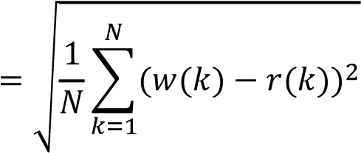

where 𝑤(𝑘)is the wheel absolute displacement and 𝑟(𝑘)is the road displacement at time step 𝑘. A lower RMSE indicates that the wheel follows the road more closely, corresponding to better traction.
Horizontal stability was assessed using the Mean Absolute Error (MAE) between the left and right wheel absolute displacements. MAE was selected because it directly measures the average magnitude of the difference in wheel motion across the axle. It is defined as
𝑁
MAE 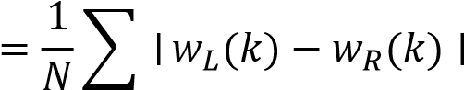
𝑘=1

where 𝑤_{𝐿}(𝑘)and 𝑤_{𝑅}(𝑘)are the left and right wheel absolute displacements. A smaller MAE indicates improved horizontal stability, as both wheels move more similarly when subjected to road disturbances.

Cruise mode results
For cruise mode, the RMSE values were 0.0482 m for the left wheel and 0.0505 m for the right wheel. These results indicate that the wheels deviate from the road surface by approximately 5 cm on average, showing moderate traction performance. The close agreement between the left and right RMSE values suggests consistent traction behaviour across the axle.
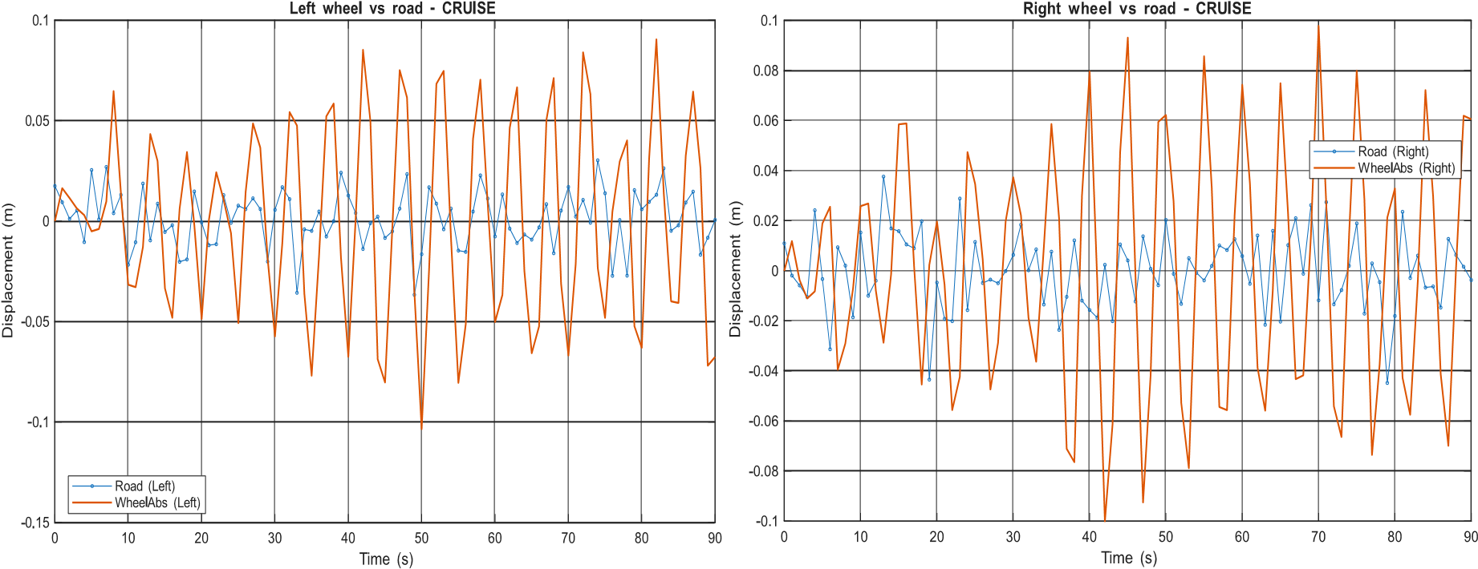
The wheel-versus-road plots show that the wheels generally follow the road profile but with relatively large oscillations compared to the road profiles. This behaviour is expected in cruise mode, as the softer spring stiffness and lower damping prioritise ride comfort rather than tight wheel control.
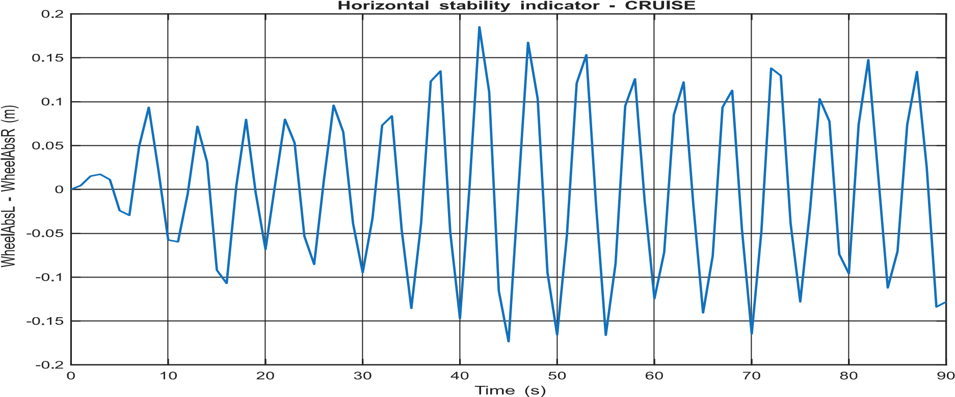
The MAE between the left and right wheel displacements in cruise mode was 0.0777 m, indicating noticeable differences in wheel motion across the axle. This suggests reduced horizontal stability, as each wheel responds more independently to its local road input. Overall, cruise mode provides acceptable traction while favouring comfort, but with reduced horizontal stability.
Sport mode results
For sport mode, the RMSE values were 0.0481 m for the left wheel and 0.0504 m for the right wheel. These values are very similar to those obtained in cruise mode.
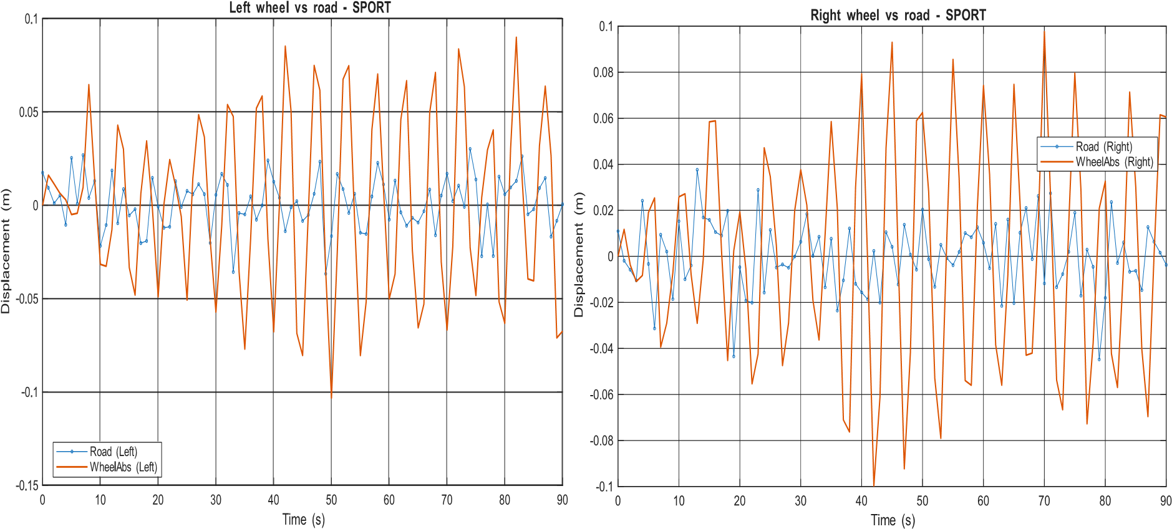
Wheel-versus-road plots shows that the wheel motion in sport mode is slightly more controlled, with reduced oscillations around the road profile. This reflects the higher spring stiffness and damping used in sport mode, which improve wheel control and responsiveness.
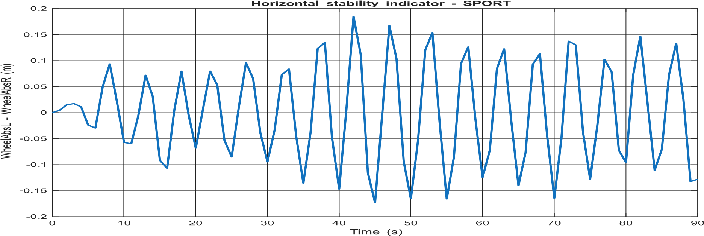
MAE for the displacement differences between the left and right wheels in sport mode was 0.0776 m, slightly lower than the value obtained for cruise mode. This shows that the improvement level in the horizontal stability is minor because the larger stiffness value minimizes the differences between the two sides of the wheels. Overall, sport mode provides better handling and stability than cruise mode with the same level of traction.
RMSE and MAE values do not seem to vary much between these two modes because of the same road profiles and a large duration of the simulation. However, much more accurate comparisons have been obtained through these two values. In the sport mode, because of additional damping and stiffness, there is a difference in the horizontal stability along with enhanced control of the wheels, although the behaviour is still similar to that of the cruise mode.

Conclusion
The report studied the dynamics of the quarter-car suspension system through cruise and sport modes using analytical models, simulation methods via Simulink, and performance indices. The susceptibility of the system to spring constants and dampers was demonstrated to have distinct benefits in terms of control or comfort. It was evident that the inclusion of the bump-stops illustrated the effects on the suspension stop and the increasing oscillations within the system. An appropriate sport suspension system was identified according to the settling time and overshoot criteria to optimize the performance and the driver comfort. Finally, whole-axle validation using realistic road profiles showed that cruise mode prioritises comfort, while sport mode provides slightly improved control and stability with comparable traction performance. Overall, the results demonstrate that the proposed suspension design meets the specified performance requirements and behaves realistically under real-world road conditions.

